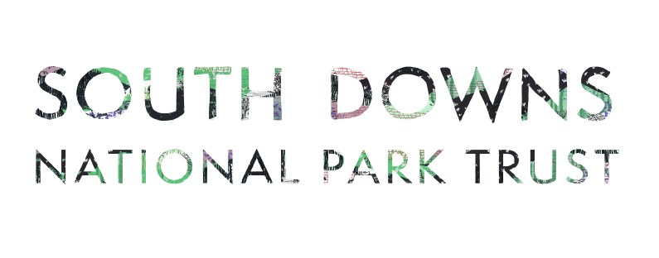
Volunteer Conservation Fund
Application Form
- Applicant details (group, organisation)
- What type of organisation are you and how are you governed? E.g. Charity, voluntary group
- Project name, location and landowner (if different from applicant)

- Have you discussed this application with anyone before submission? E.g. The Grants Officer or a South Downs National Park Ranger?
- Project summary and the intended outcomes.
- Proposed start and end date (month and year)
- Who will benefit? E.g. visitors to a park, walkers, young people from local college
- Are your activities inclusive of under-represented groups? And/or how will your organisation look to include these groups? You can read more about this here: Outcome 8: Creating Custodians

- Do you require the support of the Volunteer Ranger Service to undertake the work or to help with future activity? (This is not a requirement for an application)

- What happens after the grant funding? Please tell us about any activities you plan to continue beyond the funding.
- How will you tell others about the project?

- Project Costs - append 3 quotes for any cash expense valued at £500 and over, or explain at question 14
Item | £ (include VAT unless recoverable by your organisation)

Total

- Sources of funding - tell us about any other grants or cash you have to put towards the project costs.

From | £ Amount | Secure or pending?

Total

- How much funding are you requesting from the Volunteer Conservation Fund?

£

- Please explain if you were unable to obtain 3 quotes for individual costs over £500, telling us how the project demonstrates value for money.

A photograph of the site or land area relevant to your application is helpful, as well as examples or designs. For example, a picture of a type of fence or pond liner.

I accept the conditions of the Volunteer Conservation Fund (explained in the guidance notes) and understand that project specific conditions may be applied if a grant offer is made.

I have read and accept the data notice overleaf.
Name
Signed
Date

What happens to my data?
By providing the information, including personal information, above you consent to this information being used by the South Downs National Park Trust (SDNPT) and South Downs National Park Authority (SDNPA) for the purposes of administering, delivering and monitoring outcomes of the Volunteer Conservation Fund. Your information, including personal information will be shared with the VRS Committee in order to make decisions.

We will only contact you in relation to the Volunteer Conservation Fund.

Your contact and project details will be retained for the duration of the Volunteer Conservation Fund assessment process and for any statutory period required after the completion of the project.

The SDNPT and SDNPA may use location and project details from your application to inform future funding rounds.

Please contact us via: grants@southdowns.gov.uk if you have any questions. If you wish, at any point to withdraw your consent to this processing please notify us info@southdowns.gov.uk .
The Full Privacy notice for the South Downs National Park Trust can be found here https://www.southdownstrust.org.uk/privacy-policy/

The full privacy notice for the SDNPA can be found here https://www.southdowns.gov.uk/national-park-authority/our-work/transparency-finance/privacy-statement-2/

