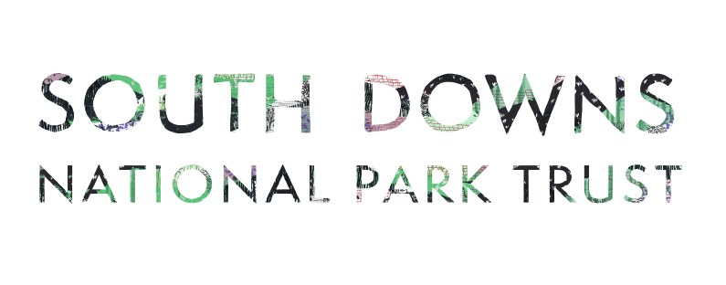
Volunteer Conservation Fund Guidance

This fund is managed by the South Downs National Park Trust in partnership with the Volunteer Ranger Service. It will allocate approximately £5,000 annually to volunteer- led projects that enhance the National Park. The average grant per project in previous years has been £2,000.

At the beginning of the year (January to March) the fund is promoted to those who are interested to apply – with all written applications to be submitted by 31 March.

If you are interested in applying to the fund please do the following:

- Read the Scope and Criteria section of this document.

- Contact the Grants Officer, grants@southdowns.gov.uk with a short description of the project including the location, your organisation/group details and whether you will need help from the Volunteer Ranger Service so that the relevant South Downs National Park Ranger can be consulted. You can then incorporate any feedback they offer when completing the application form. Use the How to complete the application form section of this document to assist you.

- Note the following standard conditions applied to any grant offer:
  - Project updates must be provided upon request
  - The final report template (available on the website ) must be completed and submitted at the end of the project
  - The South Downs National Park Trust’s support is to be recognised in all publicity material e.g. press releases, press interviews, websites, site interpretation and information boards;
  - Funds may only be used for the purposes stated in the proposal;
  - Any surplus funds must be used to improve the quality and scope of the application or returned pro rata.
  - That the involvement of volunteers in the practical completion of works is subject to appropriate health & safety, safeguarding, and risk assessment processes in line with your organisation’s policies and general good practice

We may ask that you agree the work methodology with the Ranger for the area or apply additional conditions specific to your project.

- The application form must be completed and submitted to grants@southdowns.gov.uk before the end of March in order to be considered for grant funding by the grants panel. You will be notified of the outcome by the beginning of June.

Scope and Criteria

Examples of the types of projects which have been supported in the past:
- Environmental improvement – riparian woodland work, wildflower meadow, control of invasive species
- Plug planting around a recently restored dewpond
- Equipment and materials for an orchard group
- Renovations and improvements to a wildlife viewing hide and surrounding habitat.
- Steps to a village recreation ground
- Re-fencing a dewpond
- Creating wood shingles for a historic conservation project at Butser Ancient Farm
Examples of the types of organisations that can apply:
- Not-for-profit organisations
- Voluntary/community groups
- Community interest companies
- Registered charities
- Parish Councils
- Landowners/land managers needing support to enhance environmentally sensitive areas for the benefit of the wider public. This should still be a volunteer – led project.
In order to be eligible projects must:
- Align with the South Downs National Park Management Plan (Partnership Management Plan)
- Take place within South Downs National Park Location search Projects occurring outside the National Park are not eligible.
- Be not-for-profit (commercial landowners may apply where it’s for the benefit of the wider public)
- Be environmentally and financially sustainable. Using environmentally considerate materials and able to be maintained after the funding has finished.

The types of things that the funding could be spent on are:
- Materials
- Contractors
- Specialist expertise where not available amongst your volunteers
- Consumables
- Tools and equipment
The types of things that cannot be funded are:
- Training
- Staffing costs
- Purchases you have already made
- Projects purely carried out by contractors. There should be some volunteer involvement.

You will be asked to demonstrate value for money by providing quotes for any expense valued at or more than £500, or by justifying why value for money has been met.

Match Funding and Payment Terms
Both applications for 100% of the costs and those with match funding from other sources will be accepted – projects with significant costs will require match funding.
Grants are usually paid up-front but the grants panel may agree interim payments or payments in arrears depending on the nature of the project.

Timeframe

Projects should be able to be completed within 12 months of the grant offer.

How to complete the application form

- Applicant details

The name of the person responsible for managing and delivering the project and the name of the organisation on whose behalf the application being made, for example the name of the parish council or voluntary group.

- What type of organisation are you?

E.g. CIC, Charity, Voluntary Group. How is the organization governed and managed.

- Project name, location and landowner

The name of the project and the location and landowner of the site.

- Have you discussed this with anyone before submission?

You are encouraged to email grants@southdowns.gov.uk before applying so that a South Downs Ranger can be consulted. Please also make us aware if you might need additional help from the Volunteer Ranger Service to carry out the work or future work. Volunteer Ranger Service - South Downs National Park Authority

- Project summary and intended outcomes – no more than 300 words please!

What will take place and how does it deliver against the partnership management plan for the National Park? Who is involved in delivering the project? Have you thought about sustainability e.g. recycled materials, native species, locally sourced items?

- Proposed start and end date

- Who will benefit?

Tell us what you can about how people will benefit. Visitors? Local people? Particular age groups?

- Are your activities inclusive of under-represented groups?

Tell us how you will be doing this as part of the project or what you will be doing to include these groups in the future. The information on our website will help. Outcome 8: Creating Custodians

- Do you require the support of the Volunteer Ranger Service to undertake the work or to help with future activity?

If necessary to fulfill or enhance the outcomes of your project, tell us how South Downs Volunteers would be needed. This is not a requirement but if you need the input of the Volunteer Ranger Service we will make sure this is discussed and scheduled with the relevant team.

- What happens after the grant funding?

Explain what the legacy of the project is. What will be lasting after the funding? Will any activities continue?

- How will you tell others about the project?

E.g. social media updates, Parish newsletter, open days.

- Project Costs

Outline all of the costs for this project. You can categorise costs where there are a number of small purchases i.e. Tools (billhooks, saws and hammers) - £300

3 quotes for individual expenses of £500 or more should be provided. You should include VAT unless your organisation is able to reclaim.

- Sources of funding

Include which other organisations/individuals will be contributing cash to the project and whether this has been confirmed or not. It is not necessary for match funding to be provided but applications that show other contributions will be looked upon favourably. If your match funding isn’t yet secured, any grant offered would be paid after you have confirmed your match funding is in place to continue.

- How much funding are you requesting?

When added to your other sources of funding this should be equal to your project costs.

- Value for money

If you have not been able to supply 3 quotes for cash expenses of £500 or over please explain and justify how your project achieves value for money.

- Please sign and date the application (can be electronic signature or name typed in signature box) , returning to grants@southdowns.gov.uk
- Please include any visuals that you think would be helpful e.g. site photo, example designs.

