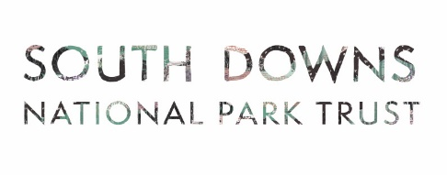
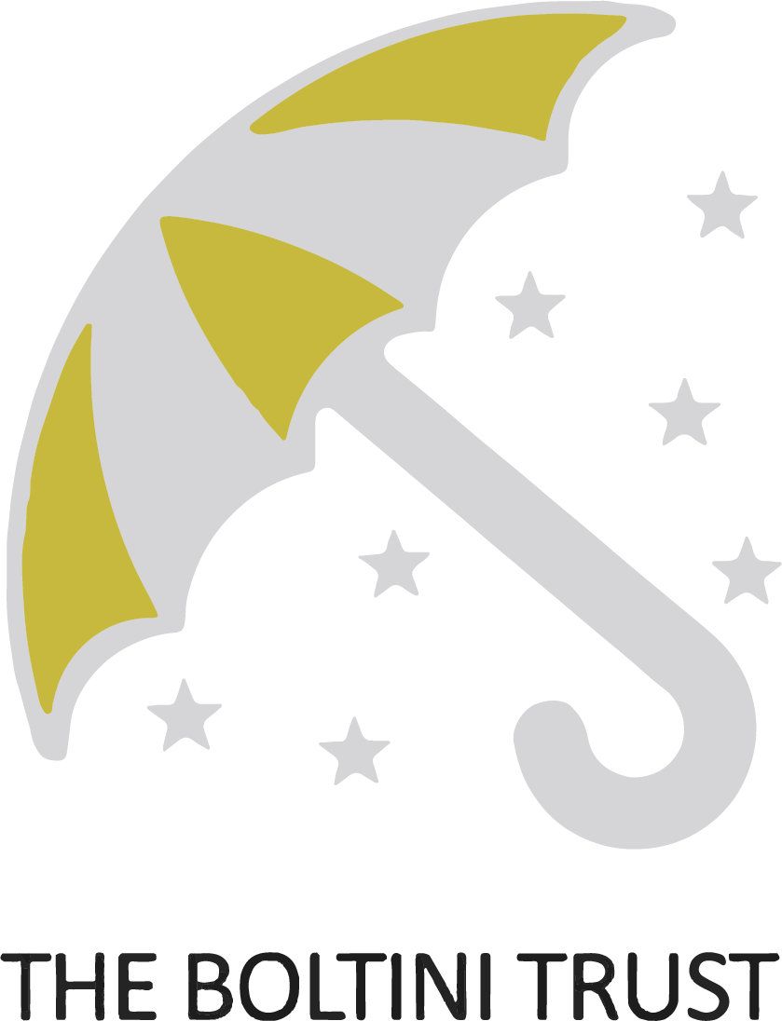
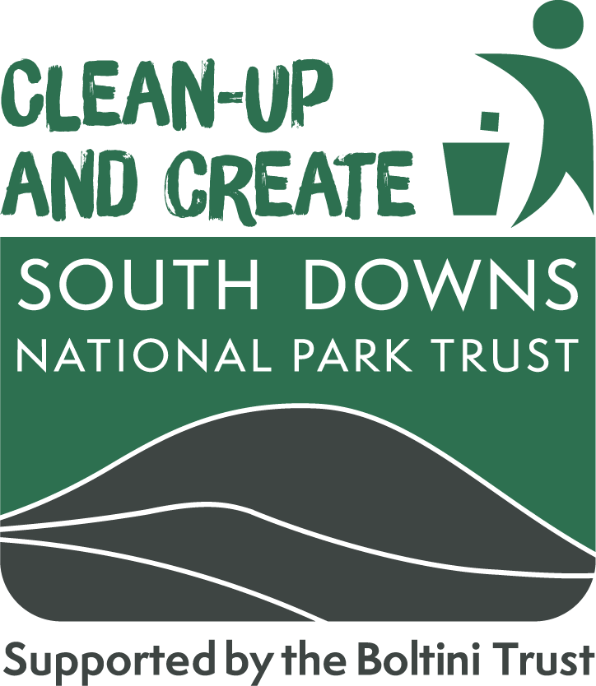

Application Form
Please read the web page before completing this form and send to grants@southdowns.gov.uk

- Applicant name and contact details:

- Who are you applying as (please highlight):
    - An individual
    - An informal group without a constitution
    - A formally constituted group (include constitution with your application)
    - A parish council
    - A partner or group coordinated by a partner such as the National Trust or a wildlife trust.

- Are you already involved in litter reduction activity? If so, how? :

- How much grant funding are you requesting:

£

- What would you use the grant to pay for and how will it reduce litter? Please list items you will purchase, the quantity and their price.

- At what locations will this activity take place?

- What plans have you made for collected waste to be disposed of or recycled?

- What have you put in place to ensure participants carry out these activities safely?

- How will you monitor and evaluate the impact of your litter reduction activity?

Please read and sign the declaration on the next page.

Applicant Declaration:

I am the applicant or have the authority to act on behalf of the applicant organisation.
I understand that if awarded a grant, it is the applicant’s responsibility to ensure that these litter reduction activities are carried out subject to appropriate health & safety, safeguarding, and risk assessment processes.
I understand that it is the applicant’s responsibility to obtain land owner permission to litter pick where applicable.
I have read the data notice.
Name
Date
Signature (electronic or type name)

Data Notice

What happens to my data?
By providing the information, including personal information, above you consent to this information being used by the South Downs National Park Trust (SDNPT) and South Downs National Park Authority (SDNPA) for the purposes of administering, delivering and monitoring outcomes of your grant. Your information, including personal information will be shared between these organisations and our funding partner, the Boltini Trust.

We will only contact you in relation to this funding.

Your contact and project details will be retained for the duration of the assessment process and for any statutory period required after the completion of the project.

The SDNPT and SDNPA may use location and project details from your application to inform future funding rounds.

Please contact us via: grants@southdowns.gov.uk if you have any questions. If you wish, at any point to withdraw your consent to this processing please notify us info@southdowns.gov.uk .
The Full Privacy notice for the South Downs National Park Trust can be found here https://www.southdownstrust.org.uk/privacy-policy/

The full privacy notice for the SDNPA can be found here https://www.southdowns.gov.uk/national-park-authority/our-work/transparency-finance/privacy-statement-2/

