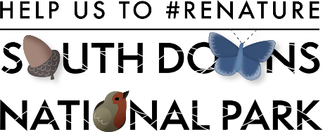

How to ReNature your School

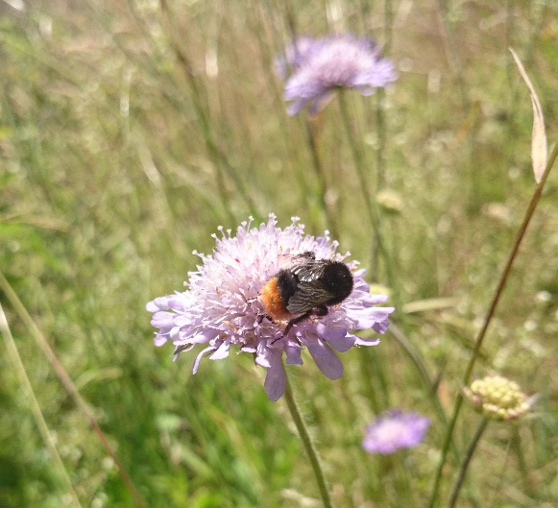

- Plant a meadow – provide a wide range of native wildflowers and you help the pollinators; planting native means you can help the caterpillars as well as the butterflies. Some bees only visit one species of flower, bumblebees have different length tongues and access different shaped flowers.
- Planting night scented flowers will attract moths, moths attract bats visiting at night.
- Plant trees – early flowering trees help bees when they emerge in spring, the leaves provide shade for everyone and food for caterpillars. Could you plant a hedge? Hedges are great habitat for lots of wildlife, including hedgehogs.
- Dig a pond – Water helps all wildlife – birds and mammals will come for a drink, frogs, toads, and newts will come to breed. Dragonflies and damselflies will lay their eggs too.
- Don’t use chemicals – using insecticides or herbicides can affect bees’ ability to fly, slug pellets can end up in the food chain – hedgehogs may eat treated slugs for instance.
- Provide a bee hotel – make a bee hotel and you will be visited by mason bees and leafcutter bees. Simply putting cut bamboo canes into an old plastic bottle or other waterproof container and hanging it up, or drill holes of different sizes (around 6mm – 12mm) into a post can create nest sites.
- Leave an area wild – leaving an area to grow and only cut in early spring – this will provide shelter for invertebrates to hide away from the weather, some bees may hibernate here and emerge in Spring.
- Have an allotment – growing your own veggies feeds you and the pollinators.
- Provide homes for birds – nest boxes in a variety of sizes and in a range of locations will attract different birds.
- Bird feeders – you could feed the birds with feeders, but make sure you clean them once a week as they can spread disease if left.
- Create a log pile, compost heap or rockery – lots of wildlife need space to hide and keep warm, piles of rocks or logs and compost heaps can be used by lizards, spiders, slow worms, and a variety of insects.

Finally - do the nature counts – RSPB Schools Birdwatch, Big Garden Birdwatch and Big Butterfly Count, City Nature Challenge. If you do this before you make changes to your grounds and then after, you should see a big difference in what you find! Recording what you find helps scientist see where nature is thriving or where it needs help.

Big Butterfly Count (butterfly-conservation.org)

citynaturechallenge.org/participate

Big Schools’ Birdwatch 2024 (rspb.org.uk)

