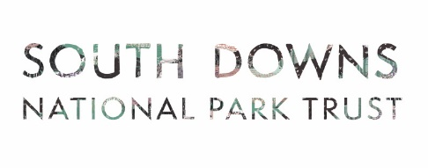
Trees for the Downs - Expression of Interest
Please read the accompanying guidance document to help you complete this form and submit it to grants@southdowns.gov.uk by 31 March 2025

Applicant checklist:

- I have read the Guidance Note before completing this form

- I have filled in my full contact details including phone number and email address

- I have provided the grid reference number for the site (Can be found here:
https://gridreferencefinder.com/)

- I have provided a map of the site. This can be a simple screenshot from online or a drawn map.

Your form may not be considered without the above information

Trees for the Downs - Expression of Interest Form
Please read the accompanying guidance document to help you complete this form and submit it to grants@southdowns.gov.uk by 31 March 2025

- Project name:
E.g. Planting at Little Green

- Applicant name:

  - Applicant address:

  - Applicant email:

  - Applicant telephone:

  - Applicant type (Farmer, Parish Council, Private landowner):

- Site address (for planting):

- Grid reference:
Northings
Eastings

please provide the Easting and Northing coordinates for the site using https://gridreferencefinder.com:
See guidance notes

- Site type:
Delete as appropriate: school/woodland/ farmland/ side of road/public space/ historic parkland/hedgerow/other

- Landowner name and address (if different from applicant):

- What is the total size of the site (in m2)?

- Please provide names of at least 3 native tree species you are interested in planting. You do not have to have fully researched but an indication is helpful. A species guide is attached at the end of the guidance notes.

- Approximately how many trees would you like to plant on this site? - tell us if you already have an idea or have received advice

- Describe the proposed site. Is it publicly accessible? Where do you think you would plant trees and why?– please provide a simple site map. If you are applying for hedge plants please tell us if there is already an existing hedgerow you are gapping-up.

- Current biodiversity - What tree, plant and animal species are present on the
site? What impact do you hope the tree planting will have? Have trees in the area or
on the site been lost to ash dieback or any other diseases?

- Have you previously received any trees from South Downs National Park?

- Are you in receipt of any other grants or funding for tree planting or woodland creation?

- For hedge only: please indicate how the hedge would be managed after planting and by who. E.g. when/how it would be cut back, laid etc. If this is grazing land what is in place to protect the hedge from grazing livestock?

- Your Resources What funding or resources are you or your partners able to bring to
the project? For example:
- In-kind contribution of equipment, materials or volunteer time to the project’s
delivery and maintenance.
- Will it be accessible for educational and/or research visits?
- Will there be any other cash contributions, for example, other grants or cash
towards larger woodland planting schemes.

