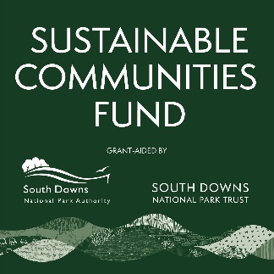
Sustainable Communities Fund

Project Enquiry Form

This form captures basic information about your project so that we can check your organisation meets the criteria for funding and obtain advice from staff at the South Downs National Park Authority. It is not necessary to have a detailed budget and quotes at this stage. Please return this form to grants@southdowns.gov.uk

Organisation name and contact details |  |  | Organisation Type | E.g. Charity, Community Benefit Society, Parish Council
What governance document do you have in place? | E.g. a constitution, memorandum and articles of association. | Does the organisation have it’s own bank account? |  | Y/N
Project location | Please give the full address and postcode. Give the main address if more than one.
Land or building owner if not proposed applicant
Give a brief summary of what you are planning to do, including who or what would benefit. List any partner organisations you would be working with. Max 300 words.

Which of our outcomes would this support? | https://www.southdowns.gov.uk/partnership-management-plan/
When would you like to start the project? | Can be an estimate.
What items or services do you need to purchase?
What is your estimated project cost?
Approximately how much funding would you request?

Privacy Notice - What happens to my data?

By providing the information, including personal information, above you consent to this information being shared between the South Downs National Park Trust (SDNPT) and South Downs National Park Authority (SDNPA) for the purposes of advising on the details of an application. Your information, including personal information, will be shared with our grants panel should advice be required relating to the grant criteria. We will only contact you in relation to the Sustainable Communities Fund. After a written response to this form, your contact and project details will be retained if your project is eligible for funding so that we can contact you about the next available grant opportunity.
Please contact us via: grants@southdownstrust.org.uk if you have any questions. If you wish, at any point to withdraw your consent to this data processing please notify us info@southdowns.gov.uk .
The Full Privacy notice for the South Downs National Park Trust can be found here https://www.southdownstrust.org.uk/privacy-policy/
The full privacy notice for the SDNPA can be found here https://www.southdowns.gov.uk/national-park-authority/our-work/transparency-finance/privacy-statement-2/

