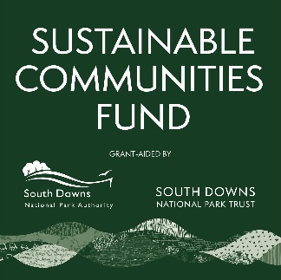
Sustainable Communities Fund

Project Enquiry Form

This form captures basic information about your project so that we can check your organisation meets the criteria for funding and obtain advice from staff at the South Downs National Park Authority. It is not necessary to have a detailed budget and quotes at this stage. Please return this form to grants@southdowns.gov.uk

Organisation name and contact details |  |  | Organisation Type | E.g. Charity, Community Benefit Society, Parish Council
What governance document do you have in place? | E.g. a constitution, memorandum and articles of association. | Does the organisation have it’s own bank account? |  | Y/N
Project location | Please give the full address and postcode. Give the main address if more than one.
Land or building owner if not proposed applicant
Give a brief summary of what you are planning to do, including who or what would benefit. List any partner organisations you would be working with. Max 300 words.

Which of our outcomes would this support? | https://www.southdowns.gov.uk/partnership-management-plan/
When would you like to start the project? | Can be an estimate.
What items or services do you need to purchase?
What is your estimated project cost?
Approximately how much funding would you request?

Privacy notice: What happens to my data?
By providing the information, including personal information, above you consent to this information being used by the South Downs National Park Trust (SDNPT) and South Downs National Park Authority (SDNPA) for the purposes of assessing proposals or administering, delivering and monitoring outcomes of any funding given. Your information, including personal information will be shared with funding partners for the purpose of providing advice on the proposal. Your contact and project details will be retained for the duration of proposal assessment and, if taken forward as a grant, any statutory period required after the completion of the project. We will only contact you in relation to this proposal. The SDNPT and SDNPA may use location and project details from your application to inform future funding rounds.
Please contact us via: grants@southdowns.gov.uk if you have any questions. If you wish, at any point to withdraw your consent to this processing please notify us info@southdowns.gov.uk .
The Full Privacy notice for the South Downs National Park Trust can be found here https://www.southdownstrust.org.uk/privacy-policy/
The full privacy notice for the SDNPA can be found here https://www.southdowns.gov.uk/national-park-authority/our-work/transparency-finance/privacy-statement-2/

