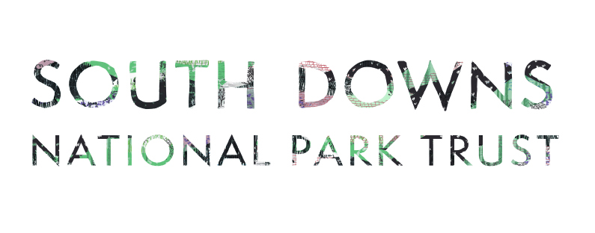

Youth Action Fund - Application Form

Please read the accompanying guidance and contact grants@southdowns.gov.uk for queries.

Include a detailed project description with this form, ideally with input from young people. Accepted formats are audio recordings, mp4 videos, PowerPoint presentations, or written statements explaining:
- The need your project is seeking to address
- What the grant is intended to be used for/spent on
- What locations activities will take place in (where applicable)
- What the impacts and outcomes will be
- Follow on actions and legacy beyond the project

- Applicant organisation name, website and postal address (where applicable)
- Lead contact name, email and phone number (must be an adult over 18)
- Name of your nominated safeguarding lead.
- Project name and location (or County where multiple locations).
- Tell us about the young people who will participate in the project. Indicate the projected number of beneficiaries and areas they will be coming from. If possible, briefly summarise demographic information, including age, gender, postcode area, ethnicity, and disability status.
- How much grant funding are you asking for? (Maximum £2,000)

£
- Please break down the total cost of your project and what this grant funding would buy.
- Please tell us about any contributions you will receive from others towards the project. For example, a grant from another charity or a business donation.
- When will the project start and finish?
- How will you evaluate the project’s outcomes?

- During your project, how would you communicate with SDNP and others about learning and achievements. E.g. social media, photo reports, public events.
- What procedures do you have in place to keep participants safe? You can share links to any of your published policies or tell us what statements/policies you hold. See declaration at end of form
- Please list the accompanying document/files you have appended with this form to ensure we don’t miss anything during assessment. Files over 10mb will need to be sent by file transfer.

Declaration | ☐I have included a copy of our organisation’s constitution or set of rules.  ☐ I understand that details of our organisation’s public liability insurance and copies of our code of conduct & safeguarding policy, and health and safety policy will be requested before a grant is offered.  ☐I understand that our organisation is responsible for safeguarding, health and safety and General Data Protection Regulation compliance if we receive funding for activities involving adults and children.

Signed:
(This person is responsible for the application’s content and must be authorised to accept grant funding.)

Name:

Date:

Please submit this form and accompanying project document to grants@southdowns.gov.uk by 10 May 2025. Files over 10mb will need to be sent by transfer.

What happens to my data?
By providing the information, including personal information, above you consent to this information being used by the South Downs National Park Trust (SDNPT) and South Downs National Park Authority (SDNPA) for the purposes of administering, delivering and monitoring outcomes of the Youth Action Fund. Your information, including personal information may also be shared with other organisations involved in the Youth Action Fund or fund donors. We will only contact you in relation to the Youth Action Fund project.
Your contact and project details will be retained for the duration of the Youth Action Fund assessment and delivery stage and for any statutory period required after the completion of the project. The SDNPT and SDNPA may use location and project details from your application to inform future funding rounds.
Please contact us via: grants@southdowns.gov.uk if you have any questions or to withdraw your consent to this processing. The Full Privacy notice for the South Downs National Park Trust can be found here https://www.southdownstrust.org.uk/privacy-policy/
The full privacy notice for the SDNPA can be found here https://www.southdowns.gov.uk/national-park-authority/our-work/transparency-finance/privacy-statement-2/

